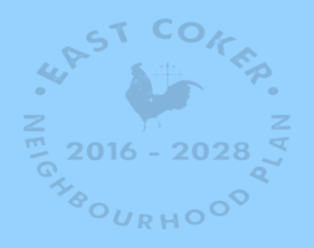
East Coker Neighbourhood Plan
Neighbourhood Plan Update January 2016

Work has progressed over the past months on the continuation of the East Coker Neighbourhood Plan. The Plan Group has taken account of views expressed by the local community, through resident and business questionnaires and as a result of the very successful consultation event, that was held in the Village Hall on 10 October 2015, when over 150 local people attended and provided an excellent input into the Plan’s development.
The Group is also engaging with the District and County Councils, as well as other agencies such as Natural England, Historic England and the Environment Agency.
Work has progressed on the writing of policies, based on the vision and objectives that were outlined at October event and which received good public support. These deal with all the subject matters addressed in the Plan, such as housing, employment and business, community facilities, the built and natural environment and transport and infrastructure. The policies in the Plan have to generally conform to both the National Planning Policy Framework and the South Somerset Local Plan.
A schedule of projects and actions is also being drawn up to go with the Plan, based on ideas put forward by the community.
Before the Plan is submitted to South Somerset District Council and then published for formal public consultation, the Group believe it is important that the community is consulted again on the working draft of the Neighbourhood Plan, with a view to ensuring that there is a broad a consensus of support for the plan and its policies.
There will therefore be another more informal Community Consultation event on Saturday 19 March 11:00-14:00 in the Dampier Room at the Village Hall, when copies of the Draft Plan, the policies and other information will be displayed and the East Coker Neighbourhood Plan Group will be on hand to answer questions.
In due course the Plan has to be ‘Examined’ by an independent Planning Inspector and also subject to a local Referendum when over 50% of those voting have to support the Plan, for it is be finally adopted or ‘Made’. This does all take time, but the Plan will then be used by both the Parish and District Councils to help determine planning applications within the Parish. The Neighbourhood Plan will then be part of the overall ‘Development Plan’ for the area.
So please make a note of the next consultation event in your diary now!
Sandra Snelling
Chair East Coker Neighbourhood Plan Group
January 2016
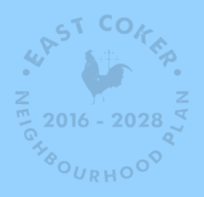
East Coker Neighbourhood Plan - Neighbourhood Plan Update April 2016

Work has progressed over the past months on the continuation of the East Coker Neighbourhood Plan. The Plan Group has been busy writing the draft plan, developing and fine tuning the policies relating to housing, employment and business, community facilities, the built and natural environment and transport, that will help guide decisions on future planning applications. These policies have to generally conform to both the National Planning Policy Framework and the South Somerset Local Plan.
Informal discussion have taken place with South Somerset’s Planning Team who have provided useful feedback. A survey has been undertaken to identify possible areas of ‘Local Greenspace’ within the village that will be identified in the Plan.
The Group is also met locally with representatives of Somerset Highways Department to discuss traffic and transport issues which has led to some proposals being included in the Plan.
A schedule of projects and actions is also being drawn up to go with the Plan, based on ideas put forward by the community and developed by the Plan Group and which could include ideas for:
- Improved Footpaths and Signing
- An information and interpretation plan to include panels about East Coker’s history to supplement existing ones, as well as updates of guided walks leaflets
- A car park for school drop off/pick up
- Speed control signs at the entrances to the village
- Other ideas for projects would be welcomed
There was a further Community Consultation event on 19 March in the Dampier Room at the Village Hall, when a new exhibition was on show together with copies of the current version Draft Plan, although this is still very much ‘work in progress’. Over xxx people attended this event which helped explain the Plan and ensure as many people as possible were well informed.
Following further amendments, the next stage will be for the Plan to be subject to formal [Regulation 14] Consultation with a wide range of authorities and agencies as well as the public. This will be for a 6 week period probably during May and June. It will then be submitted to South Somerset District Council who will arrange for the Plan to be ‘Examined’ by an independent Planning Inspector and also subject to a local Referendum when over 50% of those voting have to support the Plan, for it is be finally adopted or ‘Made’. This does all take time, but the Plan will then be used by both the Parish and District Councils to help determine planning applications within the Parish. The Neighbourhood Plan will then be part of the overall ‘Development Plan’ for the area.
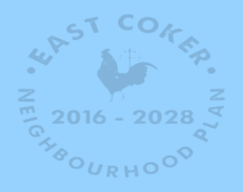
Sandra Snelling
Chair East Coker Neighbourhood Plan Group
April 2016

