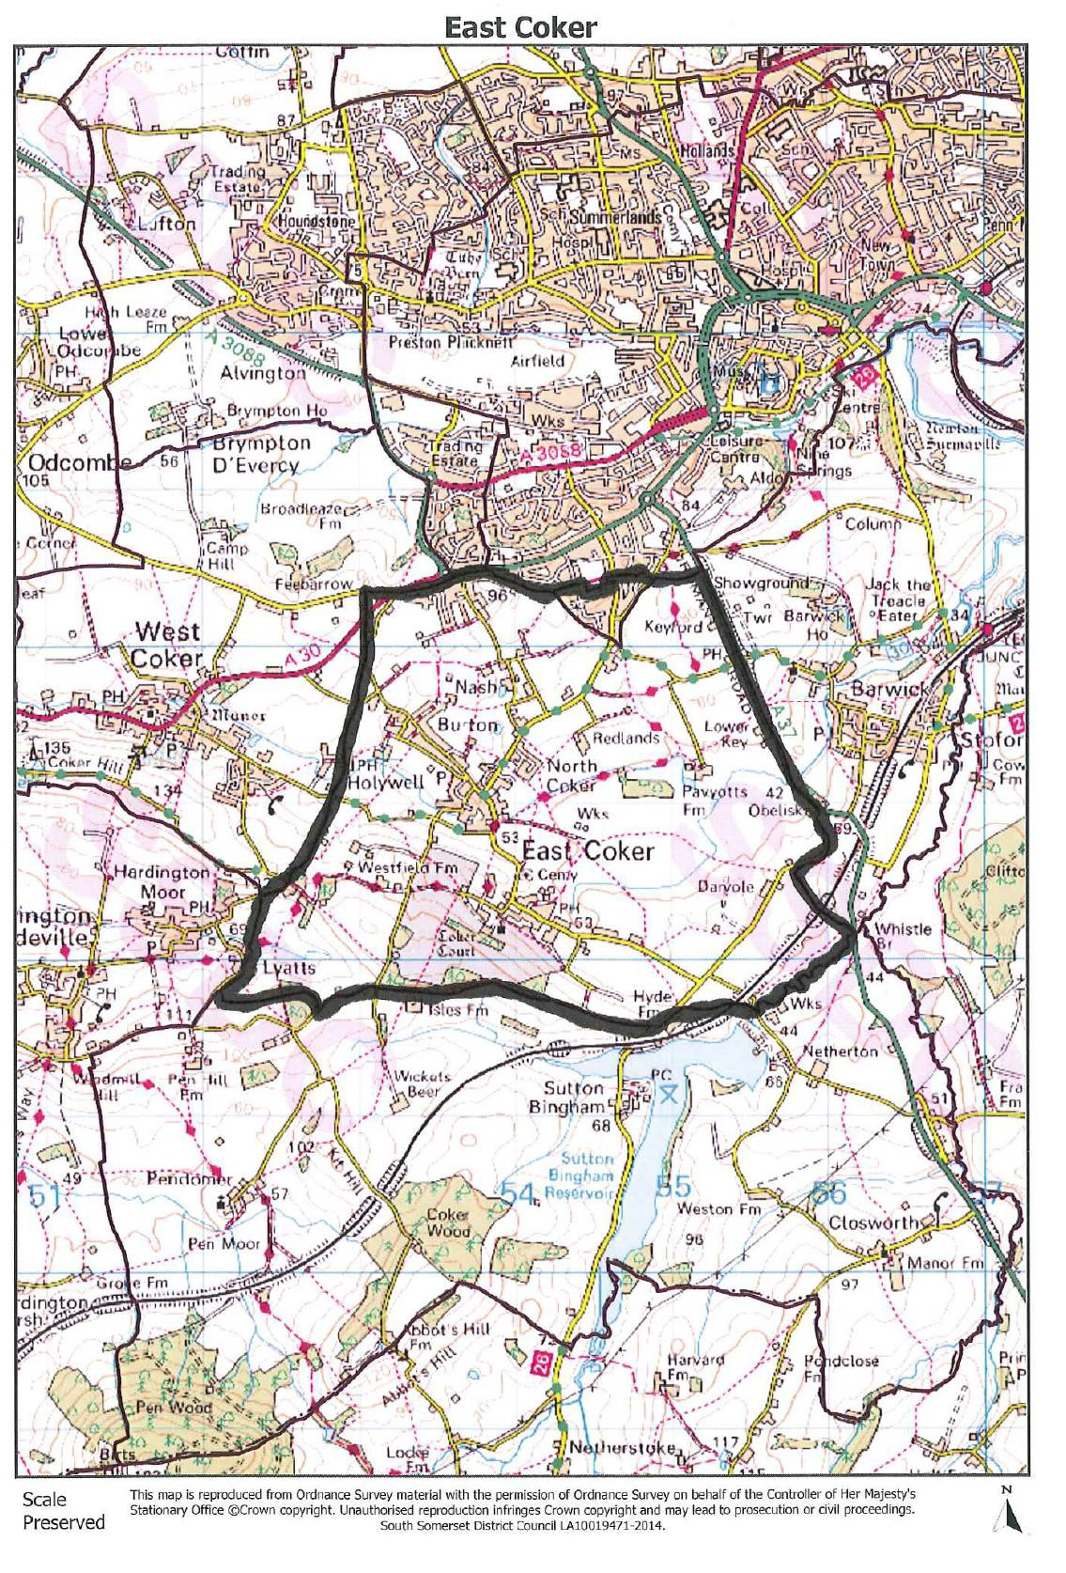

People
Age Distribution
East Coker | Parish Count 2011 | Parish  %
Total Population | 1,667 | 100%
0-4 years | 56 | 3.4%
5-9 years | 69 | 4.1%
10–15 years | 98 | 5.9%
16-24 years | 120 | 7.2%
25-44 years | 272 | 16.3%
45-64 years | 527 | 31.6%
65-74 years | 280 | 16.8%
75 years+ | 245 | 14.7%

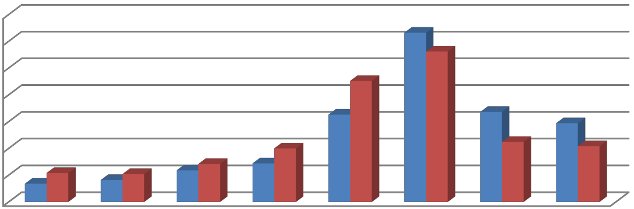
Age Distribution
35
30
25
20
15
10
5
0
0 - 4 years 5 - 9 years 10 - 15 16 - 24 25 - 44 45 - 64
years years years years
65 - 74
years
75 years+
East Coker South Somerset
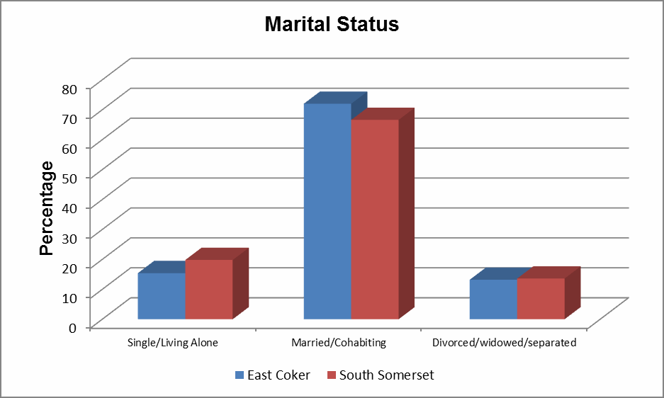

Household Tenure
 | Parish Count 2011 | Parish  % | South Somerset  %
Owned: Owned Outright | 413 | 55.8% | 38.4%
Owned: Owned with mortgatge/loan | 221 | 29.9% | 31.9%
Owned: Shared Ownership | 0 | 0% | 0.8%
Social Rented – all | 44 | 5.9% | 14%
Private rent | 49 | 6.6% | 11.3%
Living rent free | 10 | 1.4% | 1.6%
Private rented - other | 3 | 0.4% | 2%

Types of Occupation of Residents (working age)
 | Parish Count 2011 | % of Parish Residents | South Somerset (%)
Semi-routine and routine occupations | 221 | 18.4% | 28.2%
Lower supervisory and technical occupations | 84 | 7% | 8.9%
Small employers and own-account workers | 148 | 12.3% | 12.2%
Intermediate occupations | 165 | 13.8% | 12.1%
Managerial and professional occupations | 496 | 41.4% | 30.7%
Never worked and long-term unemployed | 25 | 2.1% | 2.7%
Full-time students | 60 | 5% | 5.2%

There are a small number of facilities in the village as follows:

Bank/Building Society | 0
Café/Restaurant/Takeaway | 1
Car park | 1
Cemetery | 1
Dentist | 0
Food shop (ie butcher/bakery/deli) | 0
Garden centre | 0
General store (food items & general purpose goods) | 1
GP Surgery | 0
Hairdressing salon | 1
Hall | 1
Library | 0
Non-food shop (ie gift shop, shoe shop) | 0
Pharmacy | 0
Petrol filling station | 0
Playgroup/pre-school | 1
Post office | 0
Public house | 2
School | 1
Social club | 0
Places of worship | 2
Sewage treatment works | 0
Vets | 0

Parish Council

The Parish Clerk for East Coker is: Mrs Pauline Gubbins
1 Holywell Hollow East Coker Yeovil
Somerset BA22 9NG
Tel: 01935 862062

Email: clerk@eastcokerpc1.wanadoo.co.uk

The parish council also has a website www.eastcokerparish.com, where you will find agenda’s and minutes for parish council meetings and lots of other useful information.

East Coker created a Parish Plan in 2005. A copy of which can be viewed at: http://www.southsomerset.gov.uk/planning-and-building-control/planning- policy/evidence-base/parish-plans/area-south

East Coker are also producing a Neighbourhood Plan and related information is at

http:/www.eastcokerparish.com/neighbourhood-plan

Local School

East Coker Community Primary School East Coker, Yeovil BA22 9HY
Tel: 01935 862532
Fax: 01935 864137
office@eastcoker.somerset.sch.uk Headteacher: Mr Richard Powell

Village Hall

Designed as a multi-function venue, East Coker Village Hall was built 25 years ago on land donated by the Drake family. It is on the fringe of North Coker, in East Coker parish, and overlooks the surrounding countryside.

The Hall is well maintained and hosts numerous village events and private functions, including wedding receptions.

The main hall (54’ x 32’) has a wood block floor, a stage, bar area and a servery
from the kitchen equipped with refrigerator, double sinks, microwave cooker, catering sized oven, hob and warming cabinet.

The Hall, which has wheelchair access, will accommodate 200 people, seated closely for concerts, 131 people seated at tables for a meal, and 178 people for
dancing and with tables around the edge of the hall. A tarmac car park has spaces for 64 vehicles.

For smaller gatherings the Dampier Room (32’ x 12’) is available. Hired together with the main hall it provides extra room for serving a buffet or as an alternative space for socialising away from music/dancing in the hall.

For larger events, a bar with a licence can be arranged; the bookings secretary will advise on the procedure. For the comfort of all users, East Coker Village Hall is a smoke-free building.

Hire charges include heating, lighting, hot water, use of lightweight tables (35), chairs
(200) and crockery (125 place settings).

For further information contact the bookings secretary who will be pleased to help you:

Telephone: 01935 862087
e-mail: echbookings@btinternet.com

Police Community Support

PC Pete Paskin and PCSO Tony Over Yeovil Police Station, Horsey Lane, Yeovil BA20 1SN
Tel: 101 (non-emergency number)
www.avonandsomerset.police.uk

